Chapter 14: Cost of Capital

Concept Questions:

4. WACC and Taxes: Why do we use an after-tax figure for cost of debt but not for cost of equity?

Interest expense is tax-deductible while dividends are paid in after-tax dollars. Therefore, there is no difference between pre-tax and after-tax equity costs.

5. DCF Cost of Equity Estimation: What are the advantages of using the DCF model for determining the cost of equity capital? What are the disadvantages? What specific piece of information do you need to find the cost of equity using this model? What are some of the ways in which you could get this information?

The primary advantage of the DCF model is its simplicity. The method is disadvantaged in that:
- The model is applicable only to firms that actually pay dividends (many firms do not pay dividends)
- Even if a firm does pay dividends, the DCF model requires a constant dividend growth rate forever
- The estimated cost of equity from this method is very sensitive to changes in g, which is a very uncertain parameter, and
- The model does not explicitly consider risk, although risk is implicitly considered to the extent that the market has impounded the relevant risk of the stock into its market price.

While the share price and most recent dividend can be observed in the market, the dividend growth rate must be estimated. Two common methods of estimating g are to use analysts’ earnings and payout forecasts or to determine some appropriate average historical g from the firm’s available data.

6. SML Cost of Equity Estimation: What are the advantages of using the Security Market Line (SML) approach from CAPM to finding the cost of equity capital? What are the disadvantages? What specific pieces of information are needed to use this method? Are all of these variables observable, or do they need to be estimated? What are some of the ways in which you could get these estimates?

Two primary advantages of using the SML equation from CAPM are that the model explicitly incorporates the relevant risk of the stock and the method is more widely applicable that is the DCF model, since the SML doesn’t make any assumptions about the firm’s dividends. The primary disadvantages to the SML method are:
- Three parameters (the risk-free rate, the expected return on the market, and beta) must be estimated, and
- The method essentially uses historical information to estimate these parameters.

The risk-free rate is usually estimated to be the yield on very short maturity T-bills and is; therefore, observable (at least the proxy is observable). The stock beta, which is unobservable, is usually estimated be determining some average historical beta from the firm and the market’s return data (usually the last 60 months of return data), or by using beta estimates provided by analysts and investment firms.

7. Cost of Debt Estimation: How do you determine the appropriate cost of debt for a company? Does it make a difference if the company’s debt is privately placed as opposed to being publicly traded? How would you estimate the cost of debt for a firm whose only debt issues are privately held by institutional investors?

The appropriate after-tax cost of debt to the company is the interest rate it would have t pay if it were to issue new debt today. Therefore, if the YTM on outstanding bonds of the company is observed, the company has an accurate estimate of its cost of debt. If the debt is privately-placed, the firm could still estimate its cost of debt by:
- Looking at the cost of debt for similar firms in similar risk classes (i.e., publicly-traded companies’ debt rated by credit rating agencies)
- Looking at the average debt cost for firms with the same credit rating (assuming the firm’s private debt is rated), or
- Consulting analysts and investment bankers.

Even if the debt is publicly-traded, an additional complication is when the firm has more than one issue outstanding. These issues rarely have the same YTM because no two issues are ever completely homogeneous.

10. Divisional Cost of Capital: Under what circumstances would it be appropriate for a firm to use different costs of capital for its different operating divisions? If the overall firm WACC were used as the hurdle rate for all divisions, would the riskier divisions or the more conservative divisions tend to get most of the investment projects? Why? If you were to try to estimate the appropriate cost of capital for different divisions, what problems might you encounter? What are two techniques you could use to develop a rough estimate for each division’s cost of capital?

If the different operating divisions were in much different risk classes, then separate cost of capital hurdle rates should be used for the different divisions. The use of a single, overall cost of capital would be inappropriate. If the single hurdle rate were used, riskier divisions would tend to receive more funds for investment projects, since their return would exceed the hurdle rate despite the fact that they may actually plot below the SML and, therefore, be unprofitable on a risk-adjusted basis. The typical problem encountered in estimating the cost of capital for a division is that it rarely has its own securities traded on the market. Therefore, it is difficult to observe the market’s valuation of the risk of the division. Two typical ways around this are to use a pure play proxy for the division, or to use subjective adjustments of the overall firm hurdle rate based on the perceived risk of the division.
Problems:

- Book Value versus Market Value: Filer Manufacturing has 11 million shares of common stock outstanding. The current share price is $68, and the book value per share is $6. Filer Manufacturing also has two bond issues outstanding. The first bond issue has a face value of $70 million, has a 7 percent coupon, and sells for 93 percent of par. The second issue has a face value of $55 million, has a 8 percent coupon, and sells for 104 percent of par. The first issue matures in 21 years, the second in 6 years.

- What are Filer’s capital structure weights on a book value basis?

The book value of equity is the book value per share times the number of shares outstanding, and the book value of debt is the face value of the firm’s bonds:

The book value of Filer is the sum of the book value of equity and book value of debt:

The book value weights of equity and debt are:

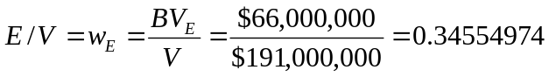

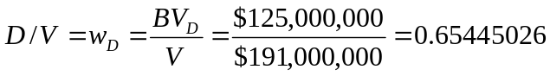

- What are Filer’s capital structure weights on a market value basis?

The market value of equity is the market value per share times the number of shares outstanding, and the market value of debt is the face value of the firm’s bonds times the market value percent of par value:

The market value of Filer is the sum of the market value of equity and market value of debt:

The market value weights of equity and debt are:

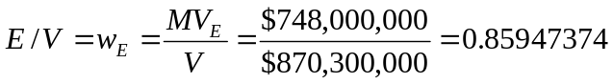

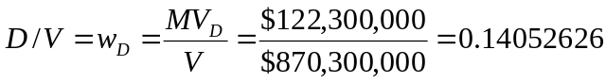

- Which are more relevant, the book or market value weights? Why?

The market value weights are more relevant. The firm’s book values represent historic costs whereas the firm’s market values represent the market’s expectations of future cash flows discounted back to the present. Since we are interested in future cash flows, we are interested in market values.

- Calculating the WACC: In Problem 12, suppose the most recent dividend was $4.10 and the dividend growth rate is 6 percent. Assume that the overall cost of debt is the weighted average of that implied by the two outstanding debt issues. Both bonds make semiannual payments. The tax rate is 35 percent. What is the company’s WACC?

First, we will find the cost of equity. The information provided allows us to solve for the cost of equity using the dividend growth model:

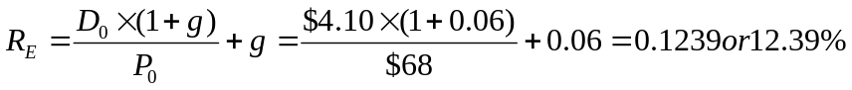

Next we need to find the YTM on both bond issues:

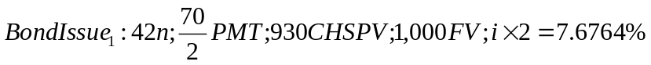

To calculate the weighted average cost of debt, we need to determine the market value weight of each bond issue. The market value weight of the first bond issue is the market value of bond issue 1 divided by the sum of market value of bond issue 1 and bond issue 2. We already know that the market value of both bond issues is $122,300,000. Therefore:

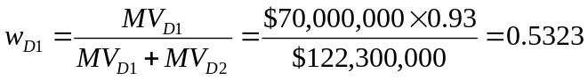

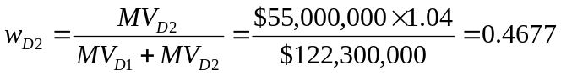

The pre-tax weighted average cost of debt is:

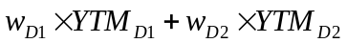

Using the WACC equation:

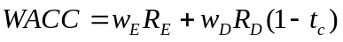

15. Finding the WACC: Given the following information for Evenflow Power Co., find the WACC. Assume the company’s tax rate is 35 percent.

Debt: 8,000 6.5 percent coupon bonds outstanding, $1,000 par value, 20 year to maturity, selling for 92 percent of par; the bonds make semiannual payments
Common: 250,000 common shares outstanding, selling for $57 per share; the beta is 1.05
Preferred: 15,000 shares of 5 percent preferred stock outstanding, currently selling for $93 per share (par value equals $100 per share)
Market: 8 percent market risk premium and 4.5 percent risk-free rate

The market values for each component are:

The total market value of the firm is:

The market value weights of each component cost of capital are:

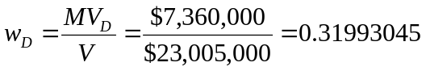

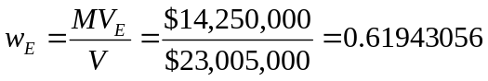

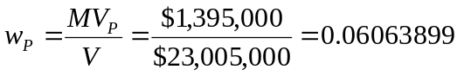

The pre-tax cost of debt is the YTM on the bonds:

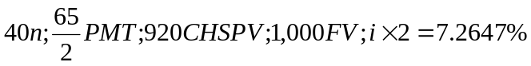

We have information to use the CAPM’s SML equation for the cost of equity:

The cost of preferred stock is:

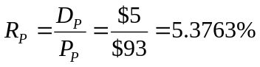

Therefore, the WACC is:

